Logging using SLF4J Exercise

# 1: Logging Error Messages and Warning Levels Task:

Write a Java application that demonstrates logging error messages and warning levels using SLF4J.

# Step-by-Step Solution:

1. **Add SLF4J and Logback dependencies to your `pom.xml` file:**

<dependency>

<groupId>org.slf4j</groupId>

<artifactId>slf4j-api</artifactId>

<version>1.7.30</version>

</dependency> <dependency>

<groupId>ch.qos.logback</groupId>

<artifactId>logback-classic</artifactId> version>1.2.3</version> </dependency>

# Create a Java class that uses SLF4J for logging:

import org.slf4j.Logger;

import org.slf4j.LoggerFactory; public class LoggingExample

{

private static final Logger logger = LoggerFactory.getLogger(LoggingExample.class);

public static void main(String[] args)

{ logger.error("This is an error message"); logger.warn("This is a warning message"); } } **Ouput:**

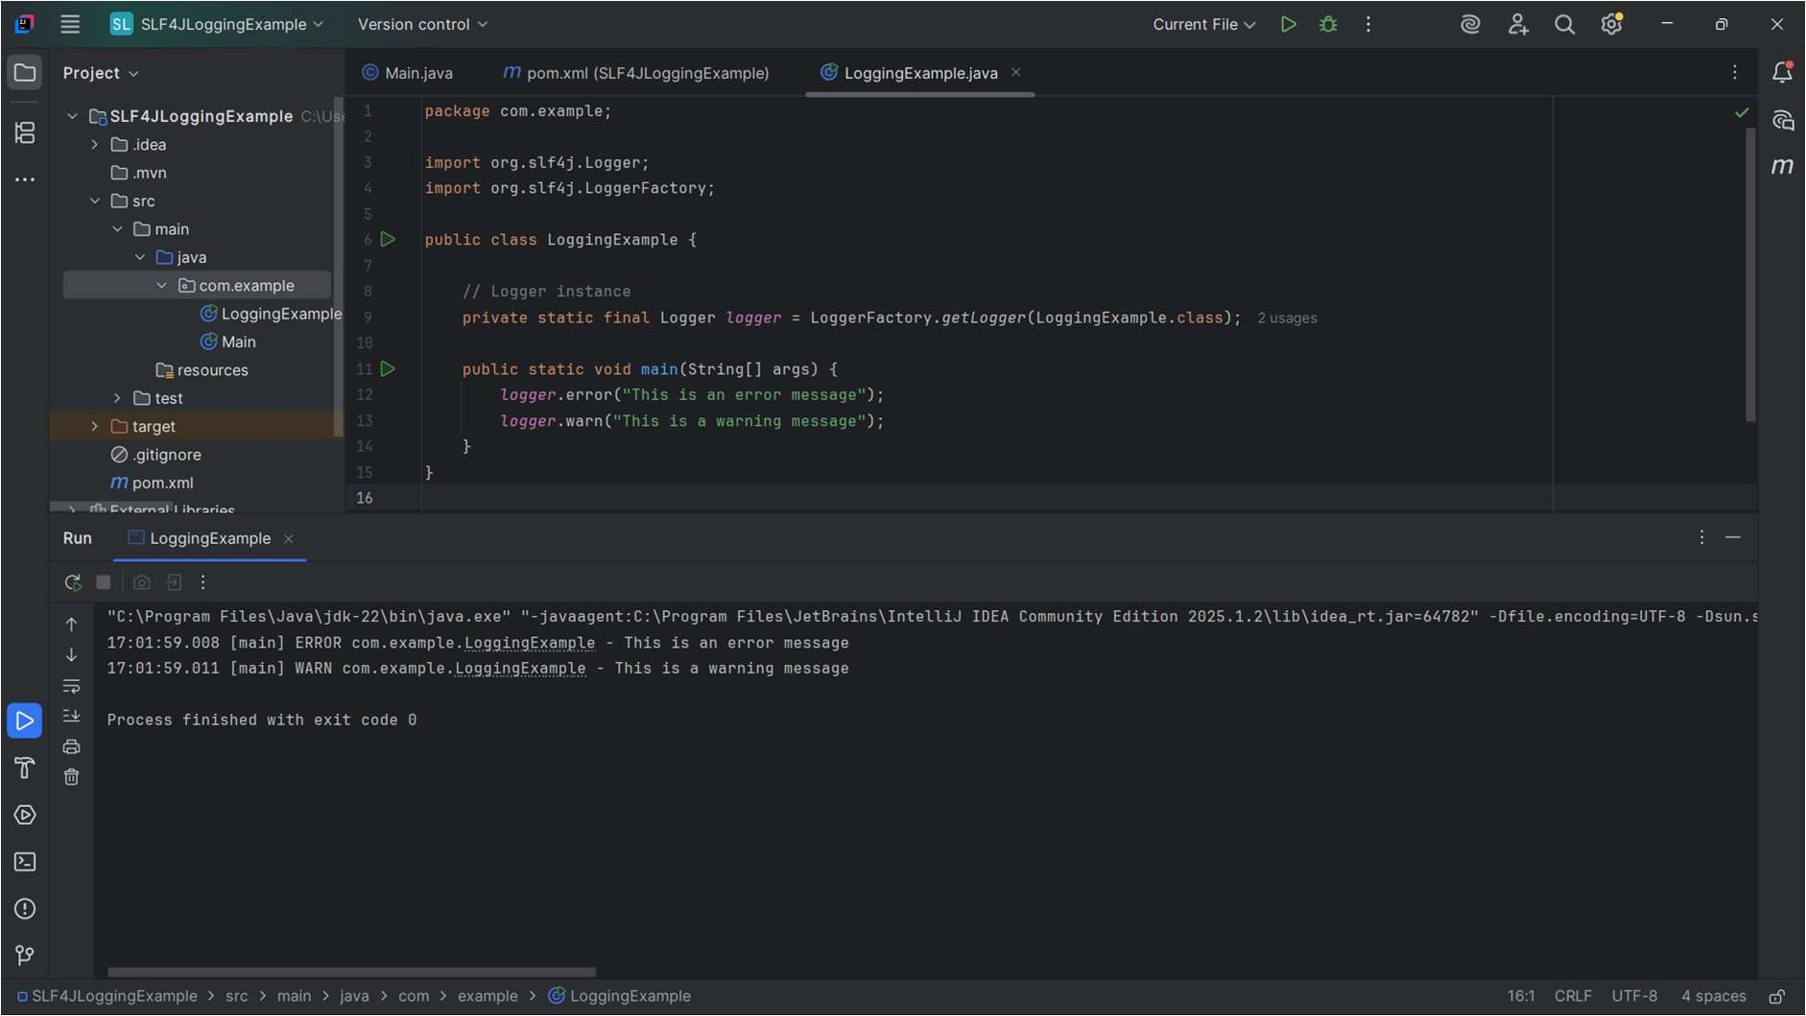

# Exercise 2: Parameterized Logging Task:

Write a Java application that demonstrates parameterized logging using SLF4J.

# Step-by-Step Solution:

1. **Add SLF4J and Logback dependencies to your `pom.xml` file:**

<dependency>

<groupId>org.slf4j</groupId>

<artifactId>slf4j-api</artifactId>

<version>1.7.30</version>

</dependency>

<dependency>

<groupId>ch.qos.logback</groupId>

<artifactId>logback-classic</artifactId>

<version>1.2.3</version>

</dependency>

# Create a Java class that uses SLF4J for parameterized logging: Output:

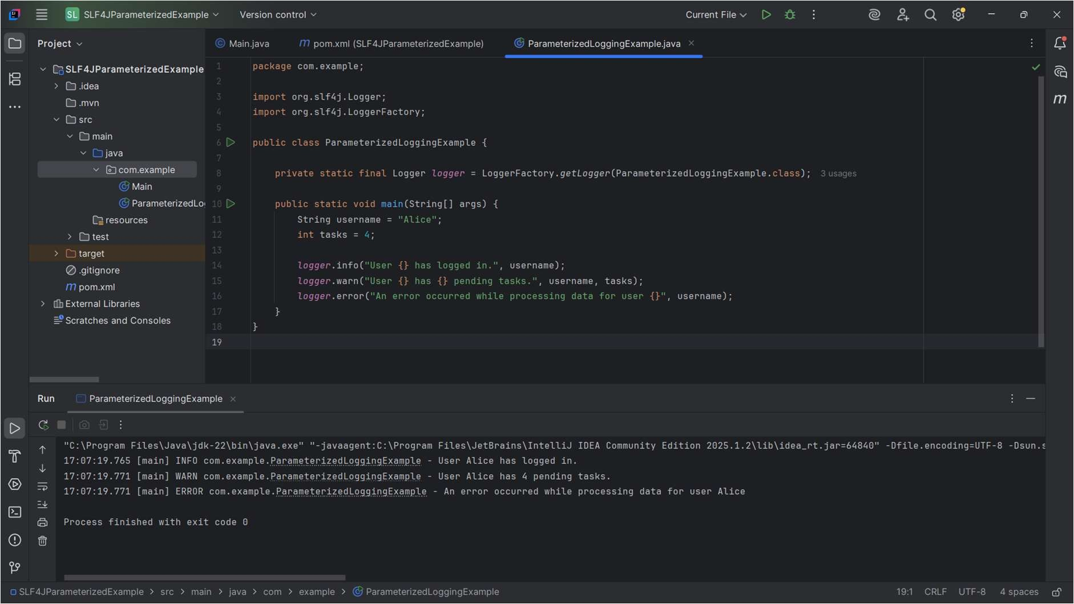

**Exercise 3: Using Different Appenders Task:**

Write a Java application that demonstrates using different appenders with SLF4J.

# Step-by-Step Solution:

1. **Add SLF4J and Logback dependencies to your `pom.xml` file:**

<dependency>

<groupId>org.slf4j</groupId>

<artifactId>slf4j-api</artifactId>

<version>1.7.30</version>

</dependency>

<dependency>

<groupId>ch.qos.logback</groupId>

<artifactId>logback-classic</artifactId>

<version>1.2.3</version>

</dependency>

# Create a `logback.xml` configuration file to define different appenders:

<configuration>

<appender name="console" class="ch.qos.logback.core.ConsoleAppender">

<encoder>

<pattern>%d{HH:mm:ss.SSS} [%thread] %-5level %logger{36} -

%msg%n</pattern>

</encoder>

</appender>

<appender name="file" class="ch.qos.logback.core.FileAppender">

<file>app.log</file>

<encoder>

<pattern>%d{HH:mm:ss.SSS} [%thread] %-5level %logger{36} -

%msg%n</pattern>

</encoder>

</appender>

<root level="debug">

<appender-ref ref="console" />

<appender-ref ref="file" />

</root>

</configuration>

1. **Create a Java class that uses SLF4J for logging: Output:**

